**STUDY OF TYPES OF NOISES**

**ABSTRACT:**

Digital image processing involves the modification of digital data for improving the image quality using computer. Digital images are generally prone to different types of noises which are undesirable. Noise in digital images may arise during image acquisition (digitization) or during image transmission. The performance of image sensor is affected by variety of reasons such as environmental condition during image acquisition or by the quality of the sensing element themselves. Images are corrupted during their transmission through the channel . Removal of noise from the images is a challenge these days and many techniques like filtering are being followed for de-noising the image.

**KEYWORDS:**

Gaussian noise, Gamma noise, Poisson noise, Speckle noise

**INTRODUCTION:**

An image basically is a two dimensional function whose value or amplitude at each point is called the GRAY LEVEL or INTENSITY LEVEL at that point. It is a collection of a finite number of elements, which are referred to as PIXELS. Noise is introduced in the image at the time of image acquisition or transmission. Different factors may be responsible for introduction of noise in the image. The number of pixels corrupted in the image will decide the quantification of the noise.

The principal sources of noise in the digital image are:

* The imaging sensor may be affected by environmental conditions like temperature
* Insufficient Light levels and dust on the screen of camera may introduce the noise in the image.
* Interference in the transmission channel may also corrupt the image.

During image acquisition or transmission, several factors are responsible for introducing noise in the image. Depending on the type of disturbance, the noise can affect the image to different extent. So we identify certain kind of noise and apply different algorithms to remove the noise.

Image noise can be mainly classified as SPECKLE NOISE , GAUSSIAN NOISE, GAMMA NOISE, POISSON NOISE.

$$A\left(x,y\right)=I\left(x,y\right)+N(x,y)$$

Where $A\left(x,y\right)$ is the noisy image

$I\left(x,y\right)$ is the original image

$N(x,y)$ is the noise

**SPECKLE NOISE:**

This noise can be modeled by random value multiplications with pixel values of the image and can be expressed as

J = I + n*I ,

Where , J is the speckle noise distribution image, I is the input image and n is the uniform noise image by mean o and variance v.

**Reasons:**

This noise is originated because of coherent processing of back scattered signals from multiple distributed points. In conventional radar system this type of noise is noticed when the returned signal from the object having size less than or equal to a single image processing unit, shows sudden fluctuations. Mean filters are good for Gaussian noise and uniform noise.

**Effects:**

This noise deteriorates the quality of active radar and Synthetic aperture radar images.

**GAUSSIAN NOISE:**

The term normal noise model is the synonym of Gaussian noise. This noise model is additive in nature and follow Gaussian or Normal distribution. Meaning that each pixel in the noisy image is the sum of the true pixel value and a random, Gaussian distributed noise value. The noise is independent of intensity of pixel value at each point. The PDF of Gaussian random variable is given by:

$$P\left(x\right)=\frac{1}{σ(\sqrt{2π)}}e^{(\frac{{\left(x-μ\right)}^{2}}{2\left(σ^{2}\right)})}$$

Where: P(x) is the Gaussian distribution noise in image;

μ and σ is the mean and standard deviation respectively.

**Reasons:**

Principal sources of Gaussian noise in [digital images](https://en.wikipedia.org/wiki/Digital_image) are

1. Acquisition e.g. [sensor noise](https://en.wikipedia.org/wiki/Sensor_noise) caused by poor illumination

2. High temperature

3. Transmission e.g. [electronic circuit noise](https://en.wikipedia.org/wiki/Circuit_noise_level).

**POISSON NOISE:**

This noise has root mean square value proportional to square root intensity of the image. Different pixels are suffered by independent noise values. At practical grounds the photon noise and other sensor based noise corrupt the signal at different proportions

**Reasons:**

Poisson or shot photon noise is the noise that can cause, when number of photons sensed by the sensor is not sufficient to provide detectable statistical information.

**GAMMA NOISE :**

This is also called as Erlang noise .The noise can be obtained by the low-pass filtering of laser based images.

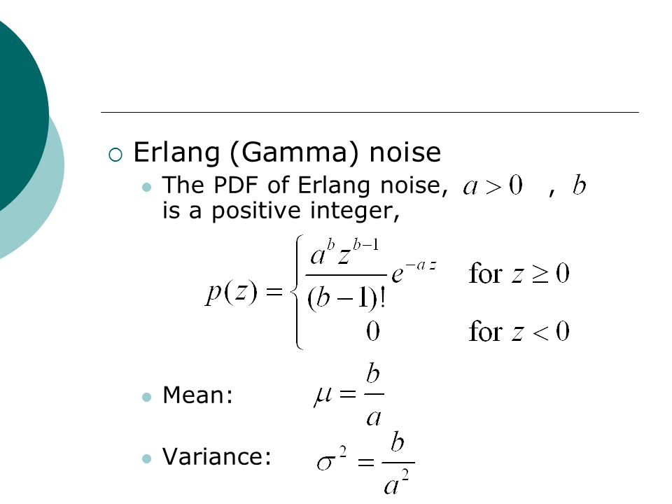

**Noise outputs:**

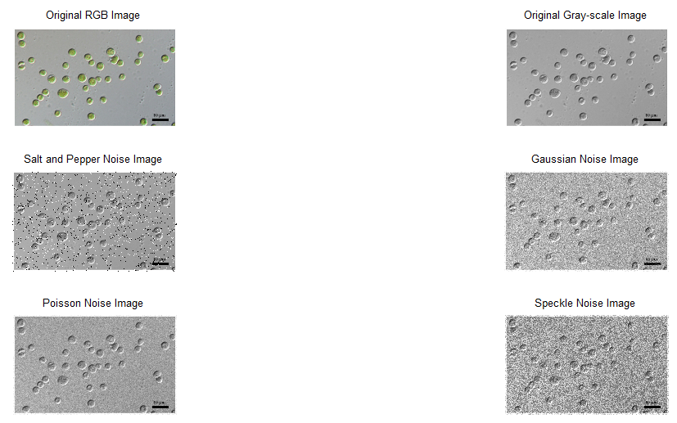

**CONCLUSION:**

Light is thrown on the causes of these noises and their major sources. Thus the different types of noise that creep in images during image acquisition or transmission were studied. Thus Salt and pepper noise was best filtered in most of the cases.